

AOD Website - <https://witchlike-sweepers.000webhostapp.com/The%20Project/>

Project Report

DT228/1

Computer Science

**Jakub Zareba**

School of Computing

Dublin Institute of Technology

**13.12.2018**



Declaration

I hereby declare that the work described in this dissertation is, except where otherwise stated, entirely my own work and has not been submitted as an exercise for a degree at this or any other university.

Signed:

________Jakub Zareba_________________

Date: 13.12.2018

Table of Contents

*1.* Problem Description 4

*2.* Research 4-5

*3.* Technology Selection and Site Architecture 5-6

*4.* Low Fidelity Prototype 6-8

*5.* Development Plan 9

*6.* Testing Plan 9-10

*7.* Site Evaluation 10

*8.* Deployment 10-11

Appendices 11-12

# Problem Description

The website offers basic knowledge about the game called “Age of Decadence”. The site content isn’t very in-depth as the game itself is very complex and even the official wiki of the game isn’t fully complete, the website made for the purpose of this project contains very basic and incomplete information regarding the game.

The website consists of five pages, each has to offer a bit of different information about the game content. The first page contains a brief description of what user can expect from the game and a gallery, which an image rotator. Next three pages consist of information about the in-game content, such as three main cities, joinable factions, and weapons available to the player.

The last page is a contact form, which user can fill to send a message to the server with all the information that user did include in the form, such as nickname, email address and gender.

An archetypical user of the website would be considered a player who has already interest in classical RPG games, such as old Fallouts or Baldur's Gate and the website's purpose is to provide the user basic information to familiarize him with the game contents and/or mechanics. As it was not the purpose to attract casual players, they still might find useful information, which can make them interested and try the game.

# Research

For the purpose of this assignment, I looked at other websites about the game and it was easy to conclude that they all were using similar color-schemes and layouts to resemble the one from the game. Background images and colors, buttons, fonts, everything was trying to look similar to in-game content, which is a fairly reasonable idea.

At first, I looked at the games wiki: [link](https://ageofdecadence.gamepedia.com/The_Age_of_Decadence_Wiki), and that gave me the general idea of how I want to style my website. The styling seems pretty simple and this is what I wanted to aim at, I wanted to stick to the simplistic layout and colors to not overdo it.

The second website I took a look at, was the website of game creators, Iron Tower Studio: [link](http://irontowerstudio.com/age-of-decadence-media). Here I could notice, that the color scheme is very similar to the one from the wiki page, but in addition, the CSS and JavaScript is way more developed. Buttons, animations, fading in and out, collapsible elements, all done in a very professional manner, also static background image that doesn't scroll with the site, which I really liked.

For the third source, I was browsing the Steam game forum: [link](https://steamcommunity.com/app/230070/discussions/), which contained lots of user content, such as screenshots, videos and useful information about the in-game content. As is was plentiful in the content, it contained very little to things that would help me choose the layout and design my own webpage.

I deviated from the idea of simple colors instead of a background image, as the websites which I researched could somehow nail it with the looks, I could not replicate the appropriate color scheme and my website looked just tacky and cheap. I decided to go with the idea that I saw on the creator's website and implement a nice image that would be static in the background and not scroll along with the contents.

That forced me to use a black outline for all my fonts, as simple white font color was not visible in some parts of the background. I feel like this gave my website a bit of a nice touch and as it wasn't intended before and my only intent was to make them more readable, it looks way better with outlined fonts.

I had other issues with the header image, as I couldn't find anything suitable in the right resolution. Because of that, I had to settle either for stretching the image and lowering its resolution by doing so, which made it look bad, or to repeat the image in the header. Fortunately, repeating was a viable option, as it fits appropriately with the width of the main block and the image is full, instead of being cut in the middle.

In general, I think the website looks pretty good and if there are changes to be made, they are very minor and they do not manifest themselves instantly (At least to me). Contents, on the other hand, it is not as in-depth as I would like it to be, but making a complex website about this particular game would probably way too long and it is not beneficial to overdo it for the purpose of this assignment, which's objective is to demonstrate our intermediate skills of CSS and basic JavaScript.

# Technology Selection and Site Architecture

HTML version used for my website was HTML 5 as it supports most of the useful features and modern tags, such as <iframe> and CSS 3.0 for the highest website efficiency.

Nowadays it is expected from a website to be responsive, so the user can access it on any of his devices, such as a smartphone or tablet, or even in some cases, smart TV. So user’s laptop and/or PC is no longer the default device on which users will browse the internet. That being said, website developers need to take all these devices into consideration while designing their websites, as having one media type not a valid option to view your website is nothing, but a limiting your potential customer base.

That's why developers deviated from the old concept of using fixed values for sizes of images or fonts, such as pixels. Instead, it is considered a good habit to set your elements to be the size of the user's viewing screen. That's the reason why I used size units such as "vh" which stands for "viewport height" or "vw" which is "viewport width". Both of these units, essentially scale to the user screen, making it the automatic process to detect the window size and set elements to appropriate values.

As you can see in my site.css file, there is no single element that has fixed size, thanks to that all media all supported and tests on PC, laptop, tablet, and smartphone were all successful. Elements are scaling properly and there isn't anything out of order. I have tested three different browsers and the website seems to work fine. I haven't tested any of the niche browsers though, but I would assume that if they do support HTML 5 and CSS 3 the website will render just fine.

# Low Fidelity Prototype

Index page Lo-Fi prototype:

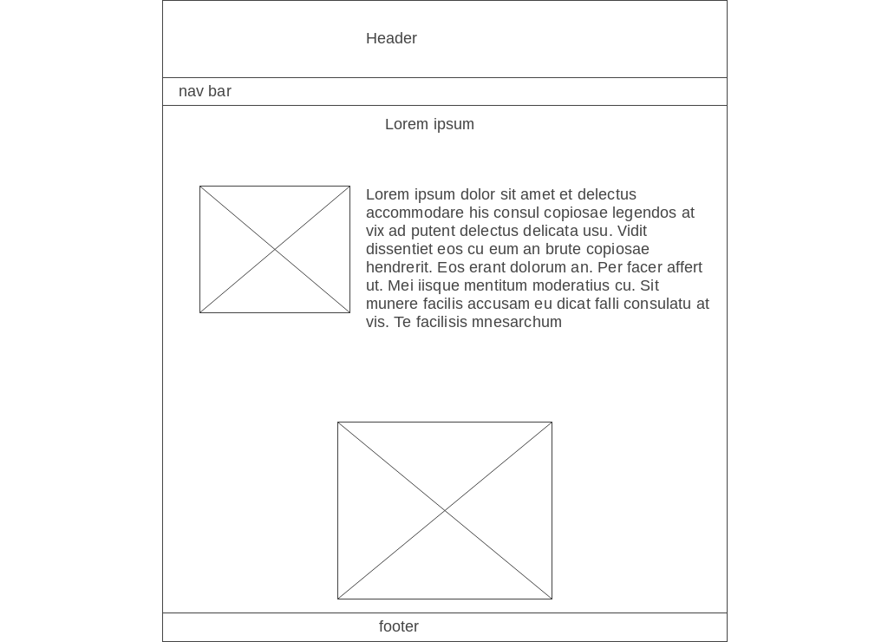

Here you can see the header, nav bar, and footer, which are all gonna be the same on every page, to keep a consistent layout. Below the nav bar will starts, the main content area. For the front-page, I went with a picture on the right along with some text, which will briefly describe the topic. Below that I made an image rotator designed for your gallery, to showcase the photos from different areas of your company, such as events or products you have done.

Locations page Lo-Fi prototype:

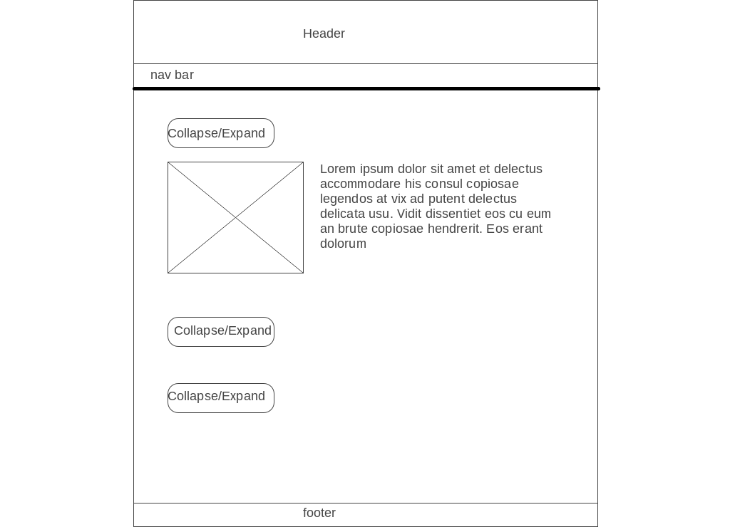

On this lo-fi prototype, you can see the location page. Of course, header, nav bar, and footer still stay the same, but the content area is different. How I designed it, is that you can put the content about your company segregated in appropriate subcategories, say, every HQ from different countries will have a brief description. The bits about specific places will be expanded after user-click and collapsed after clicking on it again. This way, you can put a lot of information on one page, without necessarily overwhelming the user with lots of content. Instead, the user can just expand bits of information that he finds interesting.

Factions page Lo-Fi prototype:

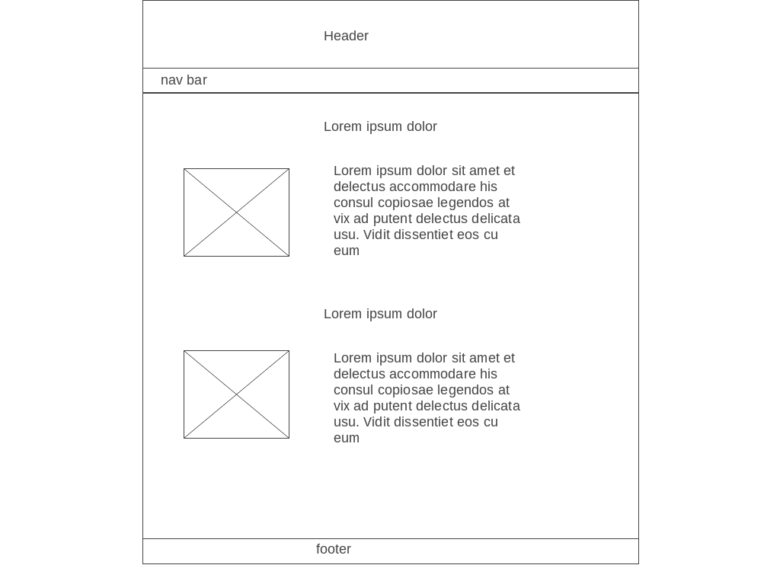

This page resembles the front page a bit. It is designed to display generic content separated by headings. Each heading will start new topic and will be followed by an image and text, but the general subject of the content will stay the same.

Weapons page Lo-Fi prototype:

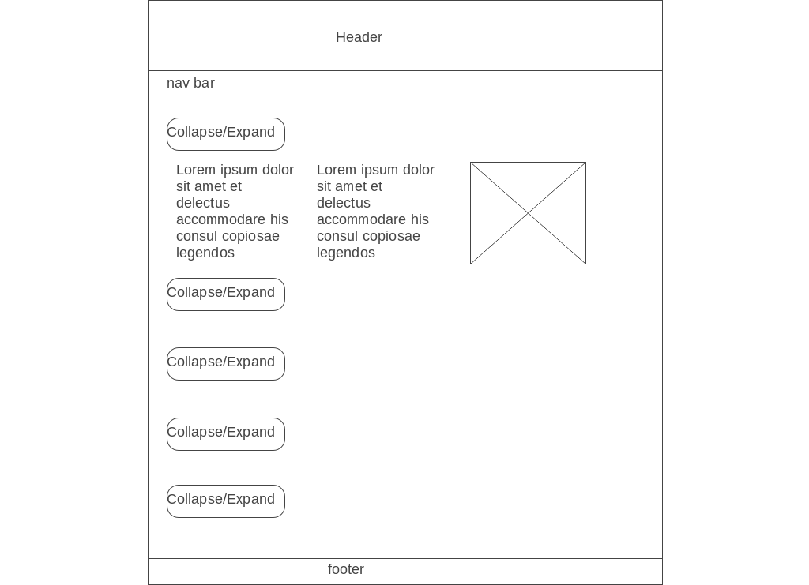

For this page, I decided to reuse the collapsible buttons, so the page is designated to hold a lot of information, that otherwise wouldn't be esthetic to display all at once. For this example I decided to fill it with tabular data, data inside can be either separated with the border or not.

Contact page Lo-Fi prototype:

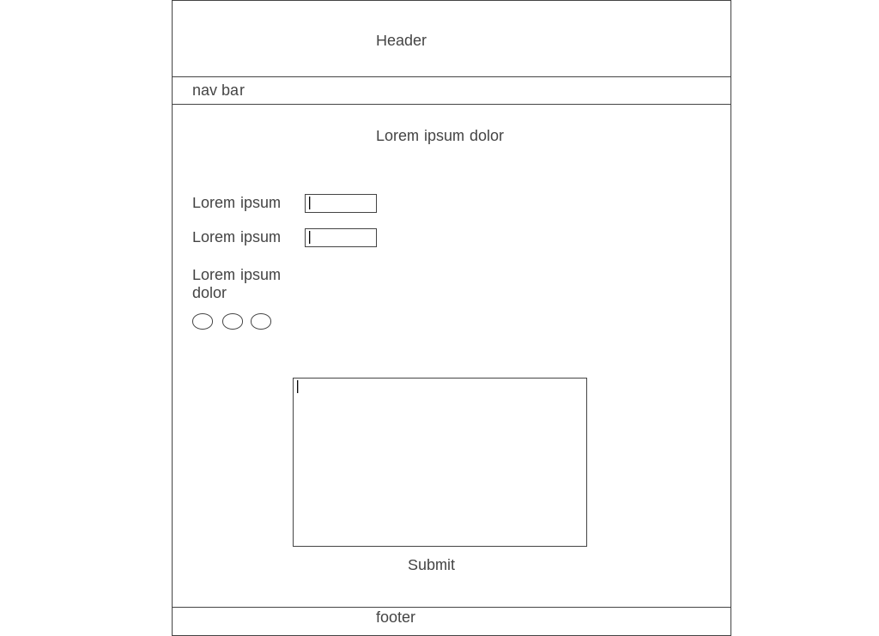

The contact page made to gather feedback about the website as well as data about our users, to see if the targeted persona is indeed the one that visits our website most frequently. It consists of few fields and checkboxes at the top and a text box made for user input at the bottom.

# Development Plan

First I had to get the concept for my website. The choice was pretty broad, as I was considering making a website for PC building, about what I am learning in the college or one of the games I like to play. You could say I want with an easy option and decided to choose one of the games I know very well. The reason for that is because I know the game really well, content will not be a problem and in need of images, I can simply make screenshots.

After topic was decided on, I had to plan what sort of content I want to include on my website, as obviously, I don't want to create another wiki page for the game, I have to pick few specific things I will write about. After having the general idea of what will be placed on the website, I started designing how to segregate the content and how it should be displayed on the website.

To be frank, I wasn't fully decided on that until the very moment of creating it. I was just experimenting and exploring my possibilities until I found something that I felt is ok and looks decent.

Obviously first, I had to make markup in my HTML to create basic elements that will be reused later on other pages, such as header, navbar, footer, and the main div. Also, to specify and style my main content image appearance, paragraphs and headings style.

After all these elements were created in markup and styled in CSS, I could easily reuse them on every next page, which significantly improved the time of developing the website. Can't imagine styling same pieces over and over multiple times.

The last step was to create javascript that would improve the website. Dynamic elements, such as collapsible buttons, contact form or image rotator, they all add flavor to the website and it looks definitely more professional.

# Testing Plan

Testing was one of the most interesting, yet the most frustrating parts of the project. It is nice to see your own creation in full display, all the elements working together, worse if they don't and you need to find the culprit. After finishing all my pages, after the implementation of CSS and javascript, the last thing that had to be done is to validate and test them.

Even though I pay a lot of attention to details, such as opening and closing tags and brackets, while validating, I could find a few stray elements that I could swear I have closed. Same missing semi-colon in CSS. It is really great such tools are available to developers these days. It showed me the line on which the code was incorrect and all I had to do is to quickly fix it.

To test if my website is working well not only on Firefox, which I use as a default web browser, I tested it as well on Chrome and Edge. All three browsers are having no issues with the website, so I would make a bold assumption it works well also with Opera, not so sure about Safari.

I dragged the window to resize it and see if the elements are scaling properly accordingly to windows size. The answer is, yes they are. I also visited my website from my tablet and smartphone and both of these devices have no problem with displaying website contents, although the free 000webhost server is so slow, it can take a good moment to load everything, especially the rotator on the index page can take a good chunk of time to load and because of that, at first it seems unresponsive and images only start to rotate after a while.

# Site Evaluation

To evaluate my website, I tested every piece of it a few times, using different browsers. I don't have too many interactive elements that rely on user input. The only page that has such elements is the contact page. I validated the JavaScript so it is required from the user to input certain things, such as his name or email. I also validated the text area so it can't be left empty to avoid users from sending empty messages.

After that, I tested it a few times with a few different input options, trying to break it, but it seems fine and users are prevented to do perform forbidden actions as planned. Next, I checked if the wording is appropriate on the website and if I want to change something. A good example here is, that on the contact page, I used "Contact Us" instead of "Contact Me" as because I think the first option seems more professional and simply sounds better.

# Deployment

To deploy my website, I created an account on the free hosting service called 000webhost, which gave me free DNS and access to their free FTP server. After having that, I downloaded and installed a program called FileZilla. In my account settings, I checked what the website's hostname is named and also it displayed me all the essential information, such as username, which is essentially the first part of the DNS it have me and password (After creation of the website).

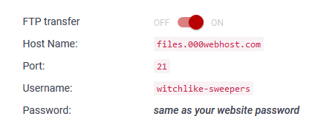

I entered all the provided information into the FileZilla in order to connect with the FTP server and then all I did, I uploaded the root folder that contains all the website components to the "public_html" folder that was already on the server. Now when I enter the address, the website appears same as in the local version, although way slower.

Well, by using a free FTP server with random DNS, the chances my website will appear on the first site in Google search are next to impossible. Nonetheless, I validated my website which means I have no stray characters all around the place, that my website structure is correct and that I have no left opened tags that I forgot to close.

# Appendices

Weekly Project Report – Week 1

For my website idea, I chose to make a website about the game named “Age of Decadence” which is one of my favourite RPG games. The game has very complex content and I chose it because I could probably write an essay of what happening there, therefore content for the website won’t be a problem.

Weekly Project Report – Week 2

This week I have created a simple wireframe for my website that clearly showed how layout on my website will look like. After creating a wireframe I made HTML files for all 5 websites that will together form the website. All 5 websites so far have basic HTML the structure along with a bit of CSS that consists for nav bar and main div.

Weekly Project Report – Week 3

For week 3 of the project, I have started doing “contact me” page and because of we learned quite a bit about form validation I plan to use that on my website. The page will consist of few user input bits, like

“Your username”, “Your email” and then text box that will allow the user to enter his message. I don’t know yet how to make that the message will be actually sent to me, but I will look into that and I try to set up a new email that would receive all the messages from users.

Weekly Project Report – Week 4

During this week I was researching similar sites about the game that I am planning to write about. I can see they all have similar colors, probably to resemble the game more as these are the same colors used in the game.

I am quite knowledgeable about the game, so I don’t really need to inform myself about the topic, but it’s always nice to see how other people approached the same topic and how they decided to divide content.

Here are the links for these sites (I will also include them in my report references):

<https://ageofdecadence.gamepedia.com/The_Age_of_Decadence_Wiki>

<http://irontowerstudio.com/age-of-decadence-news>

<https://steamcommunity.com/app/230070>

I’m currently researching the sites and well as the game to decide what should I put on my website to not make it too boring and too short at the same time.

Weekly Project Report – Week 5

During this week I was finishing the content for my website and making sure there is enough of it. Polishing minor details like the size of the paragraphs, images, fonts etc. My CSS and JavaScript are mostly done, also just a few changes to make it better. Now I only need to document everything properly and write a nice report describing what I did and what came into creating my website as well as why I went with this particular idea. The very last thing to do will be deploying my website to the web and making it public. I plan to use a free FTP hosting website that Jonathan showed us during the lectures.